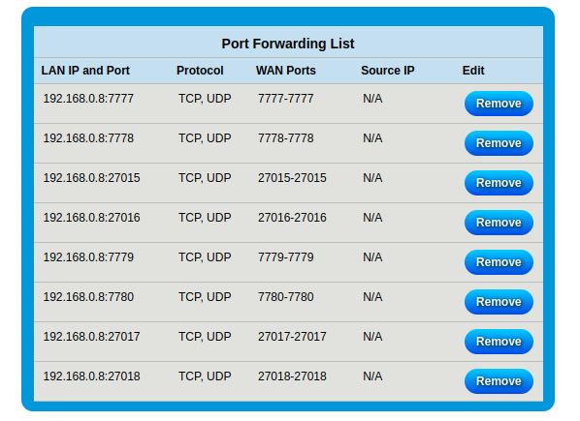

SOURCES:
https://ark.wiki.gg/wiki/Dedicated_server_setup
https://hostadvice.com/how-to/web-hosting/vps/how-to-install-an-ark-server-on-an-ubuntu-18-04-vps-or-dedicated-server/
https://playservers.medium.com/ark-survival-evolved-server-cluster-guide-1dbe0802b019
https://survivetheark.com/index.php?/forums/topic/99988-proper-way-of-doing-backups/
https://www.digitalocean.com/community/tutorials/how-to-use-journalctl-to-view-and-manipulate-systemd-logs
https://www.reddit.com/r/playark/comments/3aph4s/linux_server_help_minidump_appid_346110/
https://djangoadventures.com/how-to-increase-the-open-files-limit-on-ubuntu/

going to use systemd to run servers
server logs can be viewed with journalctl -u <server unit>.service

TODO:

HIGH IMPORTANCE:

DDNS (set it up—check on it later to see if it’s still working)

LOW IMPORTANCE:

auto update script
- update and restart script works
- can use cron to make it run automatically

figure out how to tell if an update is available, then only update if necessary
OR just reboot once a day and update

figure out how to send messages to players on the server

figure out how to tell how many people are on the server

////////////////////////////////////////////////////////////////////////////////////////////////////////////////////////////////

Used afraid for ddns
managed it with ddclient

